{#class}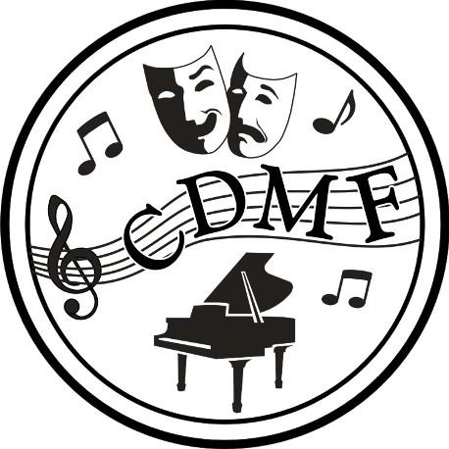

2025 CDMF Mark Sheet – Piano

{class_name}

{class_datetime}

| **{class_datetime}** | **{class_name}** | **Mark** | **Placement** |
| --- | --- | --- | --- |
| {#participants}{index} | {name} |  | {/participants} |

{/class}